**Udacity Nanodegree – Data Analyst**

***Project 1: Explore Weather Trends***

**By: Isha Talegaonkar**

**Date: 19th November 2020**

1. **Overview**

Data has been provided for average temperatures for cities around the globe as well as global average temperatures. The aim of this project is to extract the relevant data from the database and manipulate it to create informative visualisations and list down the observations.

1. **Tools used**
   * SQL – extracting relevant data
   * MS Excel – calculating the moving average, generating visualisations and making observations
2. **Extraction of Data**
   1. Selection of local data

Selected data from the city_data table to get 218 results related to the nearest city

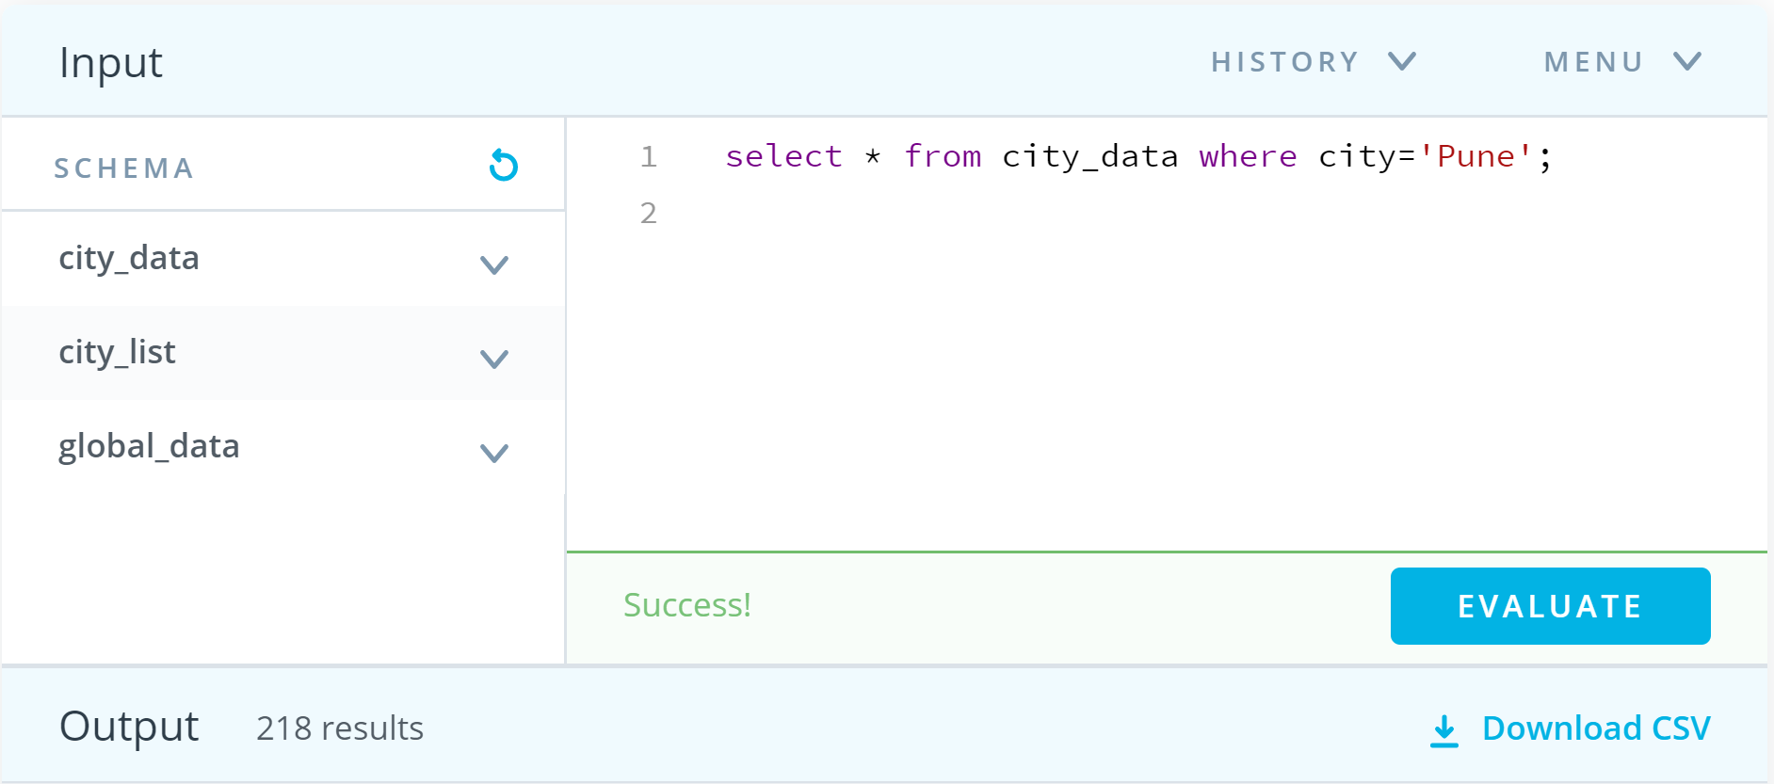

Fig. 1: SQL query to get local data

* 1. Selection of global data

Selected data from the global_data table to get 266 rows

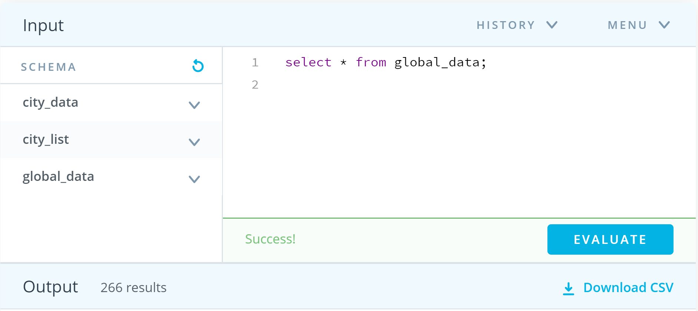

Fig. 2: SQL to get local data

* 1. Selection of local and global data using join

To match the local averages with the global averages provided for each year, a SQL query was used as shown in the figure. Once the data was extracted, and imported to Excel, various distances between years were tried to get the moving average.

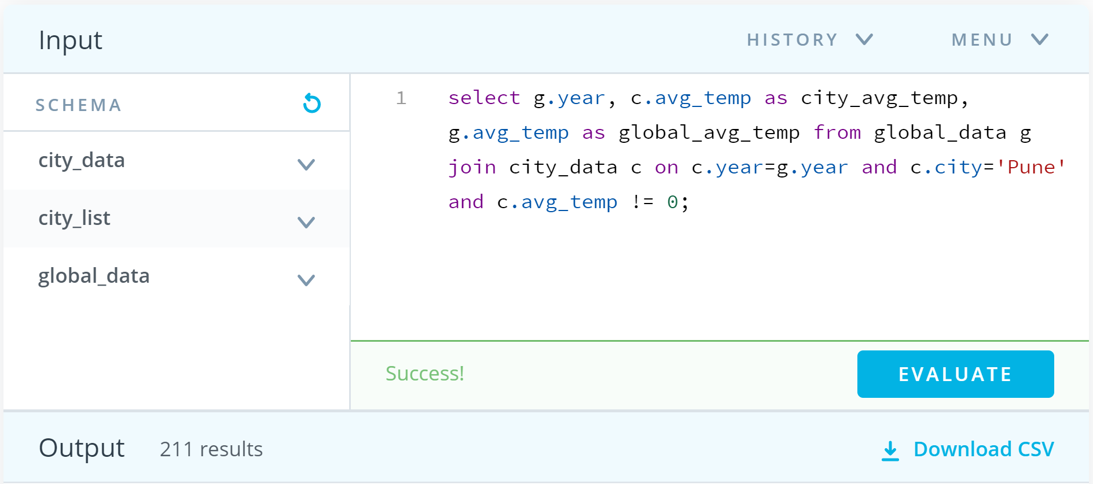

Fig. 3: SQL to get local and global data combined

1. **Data Manipulation**
   1. Calculation of moving average

* Used MS Excel Average() feature to find out 10 year moving average
* With trial and error, the 10-year moving average seemed to be the best fit

1. **Data Visualisation**

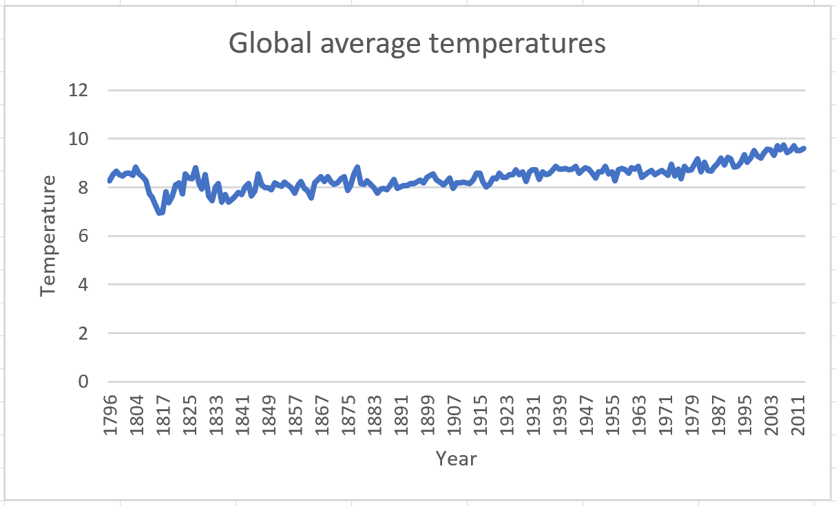 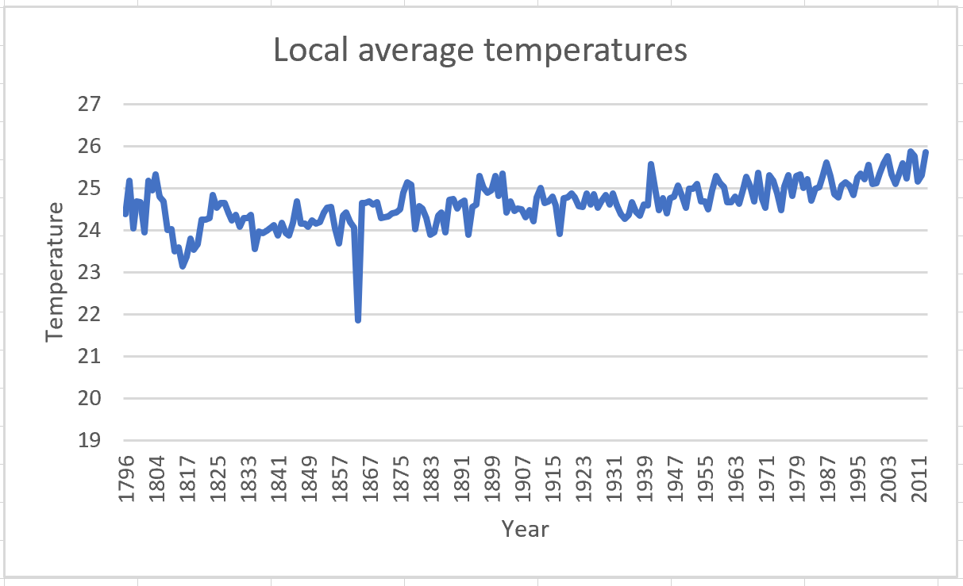

Fig. 4: Global average temperatures Fig. 5: Local average temperatures

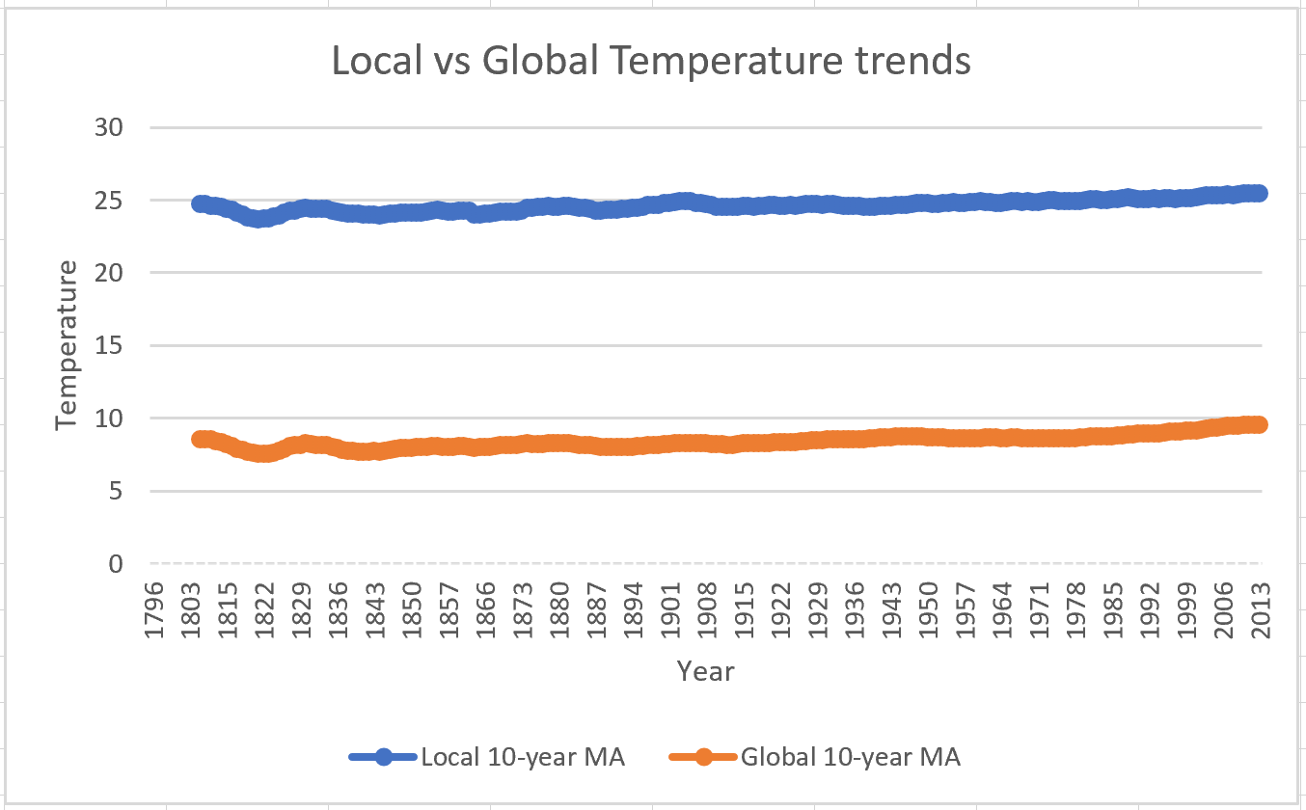

Fig. 6: Local vs Global temperature trends

1. **Observations**
2. The graph represents the average temperature trends in Pune (local – represented by the blue line) and global average temperature trends (represented by the orange line) from 1796 to 2013
3. The local average temperature for the city of Pune remains greater than the global average temperature by approximately 15 degrees throughout
4. It can be observed that when the global average temperatures decrease, the local averages decrease, and when the global averages increase, the local averages increase. For example: in 1822, there is a decrease in both local as well as global averages, and in 1829, there is an increase in local and global average temperatures
5. The local and global average temperatures increase consistently over time by approximately 1 degree Celsius
6. From figure 3, there is an exponential increase in the average temperatures globally from 1972